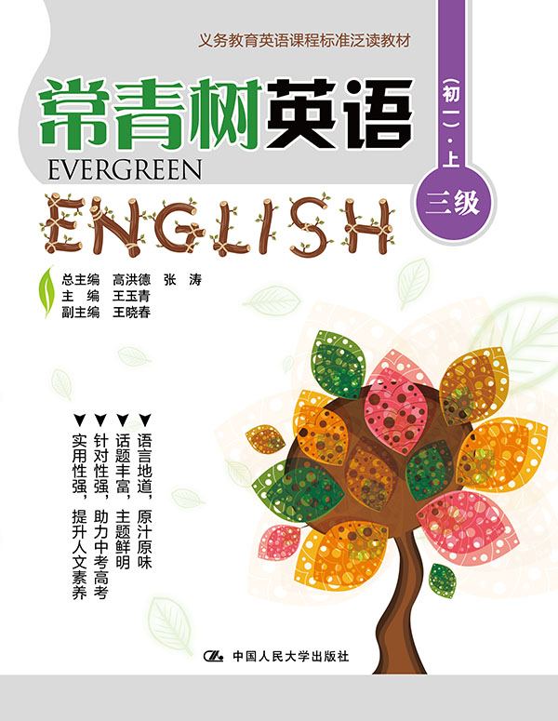
书名：常青树英语 三级（初一）·上
书号：978-7-300-21863-2
作者：高洪德 张涛 王玉青
责任编辑：李楠 黄婷
成品：177*228 页数：274
纸张：70克高白胶
装祯：平装
出版时间：2015年9月
定价：49.00元
出版社：中国人民大学出版社

- 本书卖点
- 语言地道、原汁原味
- 话题丰富、主题鲜明
- 针对性强、助力中考高考
- 实用性强、提升人文素养

◆ 读者定位
初中生

- 作者简介
高洪德，山东省教学研究室英语教研员、特级教师，中国教育学会外语教学专业委员会副理事长、山东省教育学会外语教学研究专业委员会理事长。
张涛，山东省教育学会外语教学研究专业委员会秘书长、山东省教学研究室英语教研员。

- 内容简介
《常青树英语 三级（初一）·上》适合初中起始年级学生使用，所选篇章以《课标》24个话题为主线，内容以学生的兴趣为切入点，贴近学生的生活，符合学生的认知经验和水平，渗透语言文化，有利于提高学生的学科素养。

◆ 简要目录
Lesson 1 My Family
Lesson 2 I'm From the Greatest Man's Hometown
Lesson 3 We Like Playing Basketball
Lesson 4 My Grandma and Grandpa
Lesson 5 My Father
Lesson 6 My Father
Lesson 7 Let's Be Friends in Junior High
Lesson 8 A New Star
Lesson 9 A Special Girl
Lesson 10 Father's Love on the Photos
Lesson 11 My Home
Lesson 12 Photos
Lesson 13 New Home
Lesson 14 The Country Mouse and the City Mouse
Lesson 15 Strange Houses
Lesson 16 Traveling Houses
Lesson 17 Lakes and Streams
Lesson 18 The Garden
Lesson 19 Dad's First Day at Work
Lesson 20 My New School
Lesson 21 The Bell Ring at Midnight
Lesson 22 Game Night
Lesson 23 Troop 13 Tries Too Hard
Lesson 24 India's Holi Festival
Lesson 25 The Cuddly Koala
Lesson 26 Magic Man
Lesson 27 Never Go Down Alone
Lesson 28 A Mother's Letter to the World
Lesson 29 A Pleasant Tale
Lesson 30 Susan's Secret
Lesson 31 Singing Sam
Lesson 32 How Susan Made Friends
Lesson 33 Our Lucky Money
Lesson 34 Christmas in Beijing
Lesson 35 Yard Sale Day
Lesson 36 Performing on Tryout Day
Lesson 37 Lemonade Stand
Lesson 38 In a Supermarket
Lesson 39 In a Jewelry Store
Lesson 40 Making a Bargain
Lesson 41 The Best Drink—Water
Lesson 42 Let's Have Noodles
Lesson 43 My Family's Eating Habits
Lesson 44 Table Manners
Lesson 45 Chinese Lantern Festival Food Workshop for Kids
Lesson 46 Child Health Day
Lesson 47 How to Be a Healthy Kid
Lesson 48 Sugar Addiction
Lesson 49 How to Be Safe in the Neighborhood
Lesson 50 Riding Rules
Lesson 51 Saving the Neighbor's House
Lesson 52 To Save Mother
Lesson 53 Clouds and Rain
Lesson 54 Clouds
Lesson 55 Warn
Lesson 56 Lu Han: A Good Actor, Too!
Lesson 57 Artist Uses Bananas to Create Fun Art
Lesson 58 Hue
Lesson 59 Lion Country Safari
Lesson 60 Attention, Parents and Kids of All Ages!
Lesson 61 Travelling by Train
Lesson 62 Amazing Snow Walls
Lesson 63 The Lowest Car in the World
Lesson 64 Walking to School
Lesson 65 A Good Partner for Language Learning
Lesson 66 How to Learn English Well?
Lesson 67 Learn English by Telling Jokes
Lesson 68 Tiger Tips
Lesson 69 You Can Recycle
Lesson 70 Parts of a Plant
Lesson 71 Eye-Recognition
Lesson 72 Old Fashion
Lesson 73 Writing to Your Headmaster
Lesson 74 English Names
Lesson 75 Family Weekend
Lesson 76 Table Manners in America
Lesson 77 The Golden Touch
Lesson 78 Fly and Huahua
Lesson 79 A Short Story of My Childhood
Lesson 80 Autumn Poems
Lesson 81 Spring
Lesson 82 Colors
KEY

◆ 上架建议
中学英语泛读读本

书摘
Lesson 2 I’m From the Greatest Man’s Hometown
Guidance
Is there any famous person in your hometown? Who is she/he? Do you feel proud? 你的家乡有名人吗? 他/ 她是谁? 你为此感到自豪吗?

My name is Alan. I am an old man and I’m 80 years old this year. My house is right in the middle of Stratford-upon-Avon, and I can watch the street market from my window. I live a quiet life and I enjoy reading books in the chair and taking a walk with my dog.
I live in the same town as the greatest man in England. He is famous all over the world. He is the best playwright and the best poet in England. He is a good friend to me. Who is he? Can you guess? Yes! William Shakespeare is his name.

